

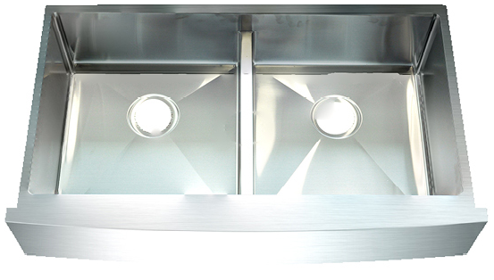

SINK DESCRIPTION
Undermount Double Bowls Farmhouse sink
16 gauge Stainless Steel 304, Satin Finish
Off-set drain location
Installation Hardware included
Proprietary sound absorbing technology that undercoats the surface of this stainless steel kitchen sink keeps it silent and protected from condensation

CUTOUT DIMENSTIONS
Template included, template number APR3117

PRODUCT COMPLIANCE

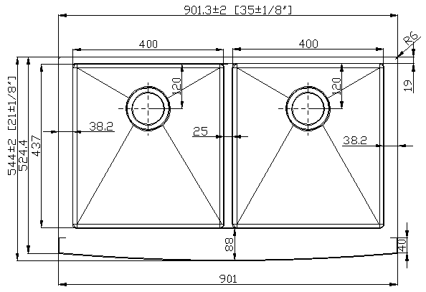
All product certified by IAPMO to meet standards ASME A112.19.3/CSA B45.4-17
WARRANTY
Limited lifetime warranty against material or manufacturing defects to the original consumer purchaser

TECHNICAL SPECIFICATION
Specification
Installation | Under-mount
Bowl area | Length: 35” (Outside)  15 3/4” (Left of Inside)  15 3/4” (Right of Inside)  Width: 21” (Outside)  17” (Left of Inside)  17” (Right of Inside)  Bowl Depth: 9”  Apron Depth:9”
Drain Hole | 4-1/2”
Template | Required, Included

 |  | 
APR3117 | 9” | Off-set

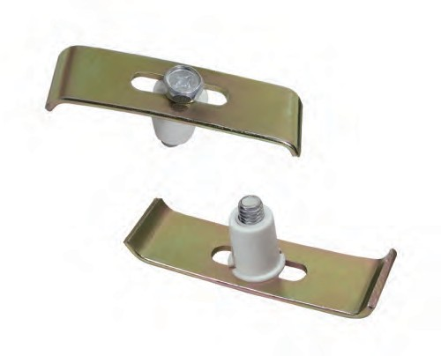

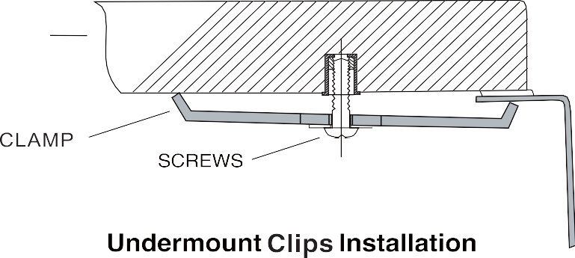

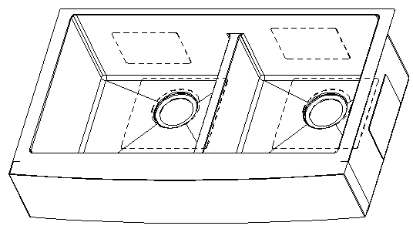

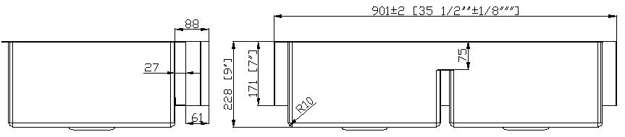

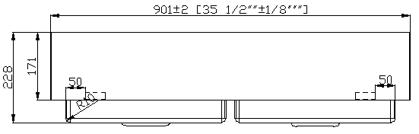

Note:
Install this product according to the installation instruction Minimum base cabinet size 36”
Consult an installer for confirmation.

FOR MORE INFORMAITON CALL: 571.393.7576
www.dynamicstonetools.com

